**Preliminary code for BeStable platform**

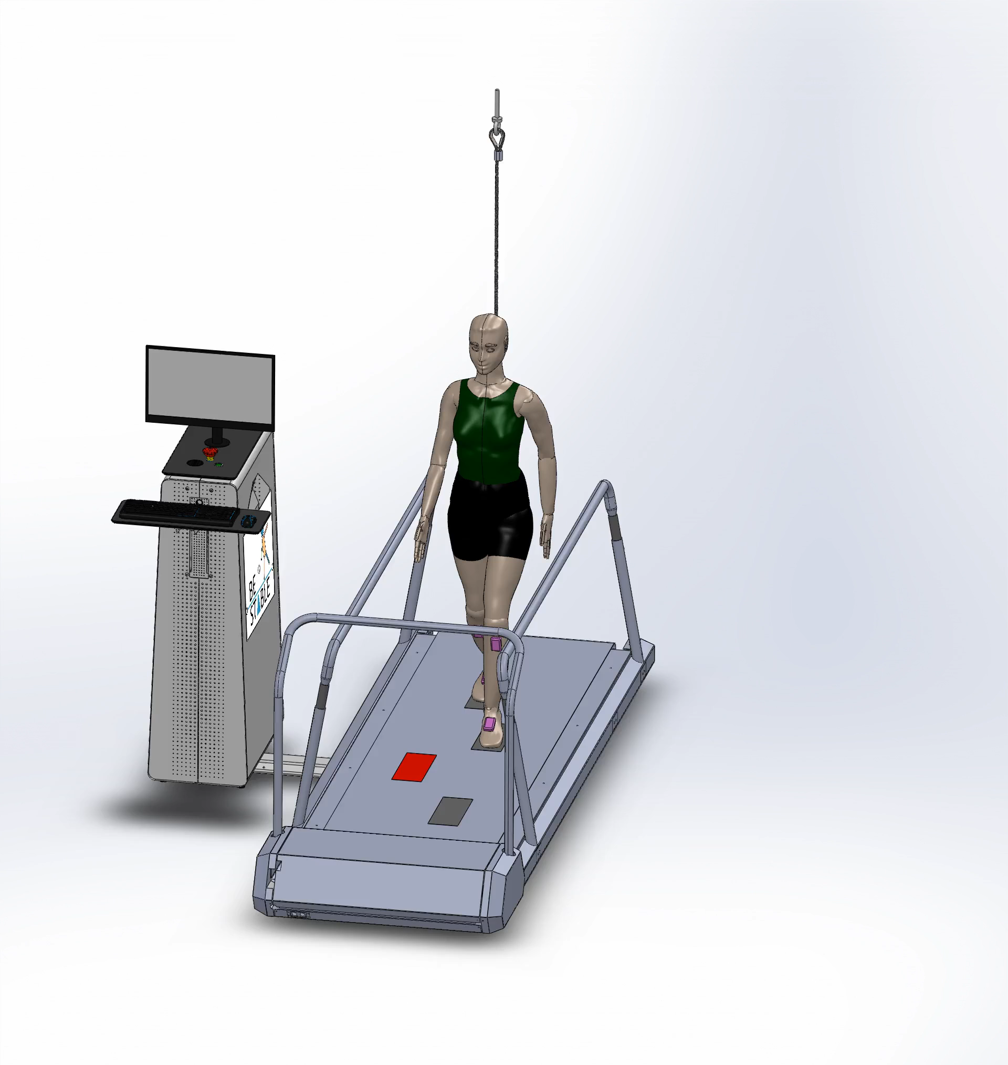

Figure 1: BeStable platform

1. **State machine**

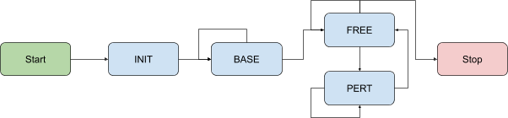

Figure 2: State machine diagram

Descriptions

* **Start**: The default state when D-Flow is started with the “Start” action button from the Runtime Console. This automatically transitions to the **Initialize** state.
* **Initialize**: Set default internal parameters. Once successful, this automatically transitions to the **Free** state.
* **Free**: Walk without targets shown
* **Perturb**: A target is shown on the walking surface of the treadmill.
* Record the following parameters every step:
  + step number
  + time stamp
  + initial limb
  + final limb
  + step length,
  + step width,
  + step time (duration),
  + target error (after disappearing visual cue)
  + message of the step characteristic
* **Stop**: The default state when D-Flow is stopped with the “Stop” action button.

1. **User interface**

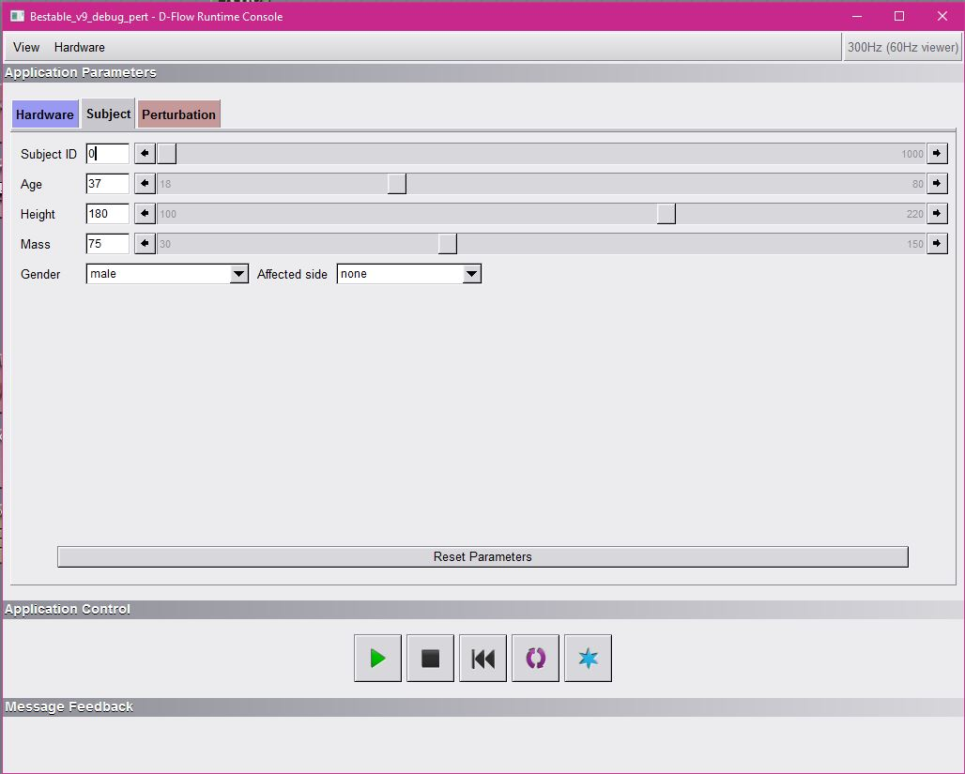

Figure 3: User interface – input subject characteristics

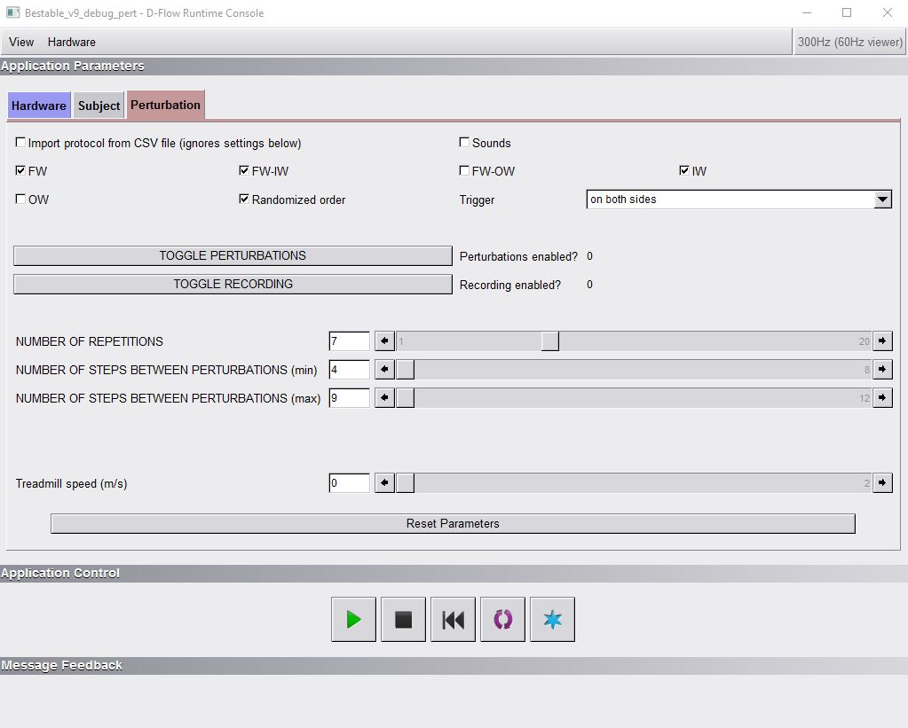

Figure 4: User interface – select and set perturbation parameters

1. **Code**

All codes running on BeStable platform are attached as the following separate files:

|  |  |
| --- | --- |
| **File name** | **Description** |
| *bestable_main.lua* | main function, state machine |
| *general.lua* | basic mathematic functions |
| *gaitDetectionGTXLib.dll* | library for IMU |
| *gtxLib.lua* | functions for IMU |
| *objectPlacement.lua* | functions for visual cue placement and sounds |
| *protocol.lua* | functions for creating perturbations |
| *bestable.lua* | additional functions, moving average, writing output data |
| *uriLib.lua* | gait detection algorithm from CoP |

1. **An example of the output file**

The example of the *output_file.csv* is attached, where subject characteristics (first two lines) and data from the measurements are stored. The following shows an example of the output file:

Table 1: An example of the *output_file.csv* from the BeStable platform.

|  |  |  |  |  |  |  |  |  |
| --- | --- | --- | --- | --- | --- | --- | --- | --- |
| ID | age | height | mass | gender | affectedSide |  |  |  |
| 0 | 37 | 1.8 | 75 | 1 | 3 |  |  |  |
| stepNumber | **timeStamp** | **limbInitial** | **limbFinal** | **stepWidth** | **stepLength** | **stepTime** | **targetError** | **message** |
| 1 | 14.62338532 | R | R | 0.019934174 | 0.045019359 | 0.04 | -1 | free |
| 2 | 15.23005198 | R | L | 0.00722311 | 0.063710654 | 0.093333333 | -1 | free |
| 3 | 15.93338532 | L | R | 0.252779696 | 0.472348443 | 0.796666667 | -1 | free |
| … | … | … | … | … | … | … | … | … |
| 32 | 49.53535111 | L | R | 0.191800449 | 0.511645719 | 0.783333333 | -1 | free |
| 33 | 50.43868444 | R | L | 0.19222166 | 0.478648364 | 0.716666667 | -1 | Pert: fwiw (R) |
| 34 | 51.35535111 | L | R | 0.341273615 | 0.817996197 | 1.023333333 | -1 | action |
| 35 | 52.08535111 | R | L | 0.347576107 | 0.272384992 | 0.69 | 0.015461387 | target hit |
| 36 | 52.85245746 | L | R | 0.180584256 | 0.480551683 | 0.85 | -1 | free |
| 37 | 53.63846364 | R | L | 0.167030066 | 0.501109838 | 0.772108089 | -1 | free |
| 38 | 54.48972629 | L | R | 0.166231278 | 0.481760327 | 0.834337778 | -1 | free |
| 39 | 55.22972629 | R | L | 0.169267375 | 0.473764102 | 0.771262649 | -1 | free |
| 40 | 56.05305963 | L | R | 0.164395532 | 0.487504169 | 0.81 | -1 | free |
| 41 | 56.80957504 | R | L | 0.159972916 | 0.468546106 | 0.753333333 | -1 | free |
| 42 | 57.60624171 | L | R | 0.163537153 | 0.528303927 | 0.839848747 | -1 | free |
| 43 | 58.36290837 | R | L | 0.152343318 | 0.469841308 | 0.753333333 | -1 | free |
| 44 | 59.17274439 | L | R | 0.16651024 | 0.470625822 | 0.796502684 | -1 | free |
| 45 | 59.90098645 | R | L | 0.169050727 | 0.47556727 | 0.73 | -1 | free |
| 46 | 60.83440014 | L | R | 0.172413276 | 0.451774603 | 0.768242062 | -1 | Pert: fw (L) |
| 47 | 62.07921998 | R | L | 0.152264081 | 0.906792767 | 1.055711787 | -1 | action |
| 48 | 62.69588665 | L | R | 0.182199787 | 0.277610428 | 0.875855076 | 0.00857886 | target hit |
| 49 | 63.46588665 | R | L | 0.200627622 | 0.535225351 | 0.863333333 | -1 | free |
| 50 | 64.23588665 | L | R | 0.197666949 | 0.436199215 | 0.796666667 | -1 | free |
| 51 | 65.00588665 | R | L | 0.192569566 | 0.497996065 | 0.743333333 | -1 | free |
| 52 | 65.78921998 | L | R | 0.175014517 | 0.452498054 | 0.77 | -1 | free |
| 53 | 66.52921998 | R | L | 0.177355289 | 0.489733235 | 0.77 | -1 | free |
| 54 | 67.29921998 | L | R | 0.166294421 | 0.461086 | 0.756666667 | -1 | free |
| 55 | 68.37921998 | R | L | 0.175160002 | 0.473433837 | 0.78 | -1 | Pert: fwow (R) |
| 56 | 69.36588665 | L | R | 0.190616928 | 0.837045781 | 1.15 | -1 | action |
| 57 | 70.17588665 | R | L | 0.200079409 | 0.476791853 | 0.903333333 | 0.178416793 | target missed |
| 58 | 70.90588665 | L | R | 0.189284172 | 0.441820289 | 0.77 | -1 | free |
| 59 | 71.78255332 | R | L | 0.156163852 | 0.482645907 | 0.81 | -1 | free |
| 60 | 72.56588665 | L | R | 0.172234126 | 0.455091758 | 0.876666667 | -1 | free |
| etc... |  |  |  |  |  |  |  |  |

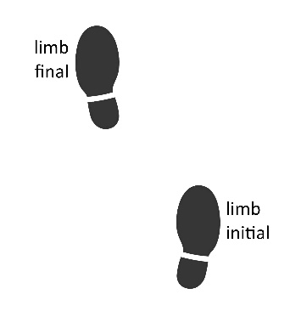

Figure 5: Initial and final limb

Target location is visualized as a blue rectangle (for the right leg) or red rectangle (for the left leg). Target error is calculated as a minimum distance between CoP and target position, i.e. center of rectangle, in a time window when target is visible. The target is displayed at the heel strike of the opposite leg and it disappears one gait cycle after.

1. **Script for signal post-processing**

The data from the measurement is segmented to the following structures:

1. BASE walking: unperturbed walking before enabling perturbations;
2. FREE walking: unperturbed walking between consecutive perturbations;
3. PERTURBATIONS: all perturbations are sorted based on their directions:
   * 1. fw as forward direction,
     2. iw as inward direction,
     3. fwiw as forward-inward direction,
     4. ow as outward direction,
     5. fwow as forward-outward direction,

and target foot:

1. (L) as visual target for left foot (red rectangle), and
2. (R) as visual target for right foot (blue rectangle).

Step width, length and time of four consecutive steps after perturbation onset are stored to the perturbation structure.

1. **Visualization of the measurement**

The report of each measurement can be displayed as shown in Figure 6.

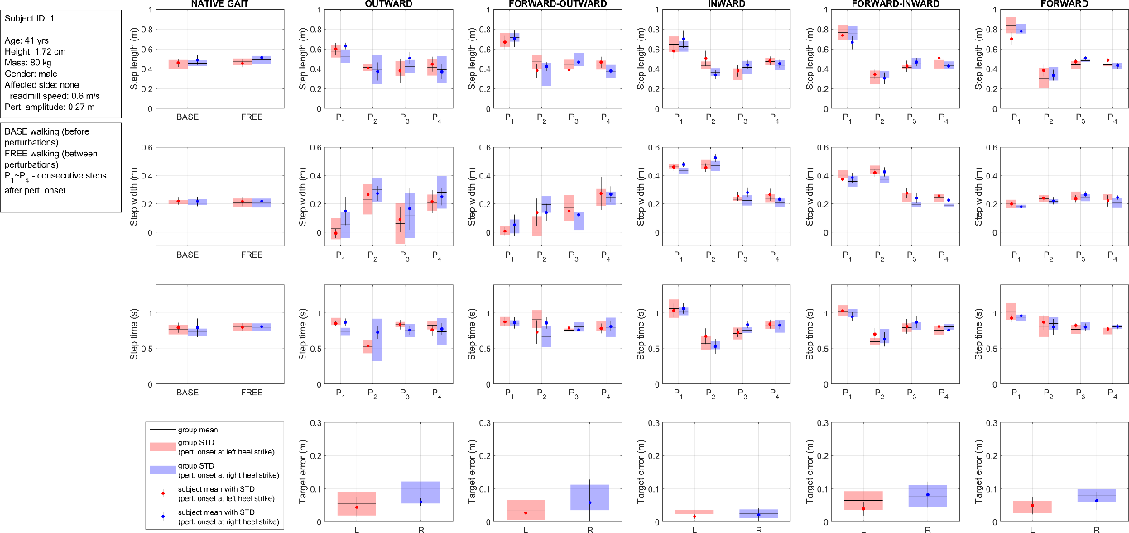

Figure 6: Presentation of the measured data of the subject compared to the group normative.